

Kindergarten News

Sight Words Review

I, is, to, a, the, was, like, me


Upcoming events

November 5th – Picture Retake Day
November 9th – Professional Learning Day. No school for students.
November 12th – Remembrance Day Holiday. No school for teachers and students.
November 16th – Report Cards go home.

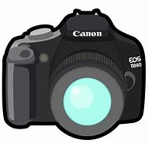

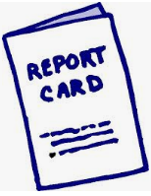

Notes from the teacher:
Our NB Student Leadership Conference last Friday was a success! The students were engaged with literacy activities lead by high school students from across the province.
Please sign up for FreshGrade!
The cold and wet weather is here. Students are expected to wear their snow pants or splash pants when we go outside and expected to dress themselves. Thanks for continuing to practice! (We will always help with tricky zippers ☺)
Students are continuing to work on not blurting. Keep it up!
If you have any questions or concerns please feel free to contact me at rolly.sidik@nbed.nb.ca, or call the school.




What we are learning this week:

Reading | Writing | Math | You and Your World
- New Letters: U, L  - Sight Words Review:  - is, to, I, me, a, like, was, like, me  - Strategy: Eagle Eye – Look at the picture.  - Review letters: s, a, t, i, p, n, c/k, e, h, r, m, d, g and o   | - Practice writing proper letter formations for: u, l, o, p, n, t, i, s, a, c/k, e, h, r, m, d, g, o  - Practice reading, writing and spelling sight words: was, the, is, me, I, to  - Practice writing their names | - Counting forwards & backwards to 5  - Subitizing ( Recognize a familiar arrangements of objects at a glance)  - Relate a numeral to its quantity 0 to 5  - Identify, create and reproduce patterns | - Roles and responsibilities of family members.  - W.I.T.S. Strategy  - Habit 1: Be proactive.  

